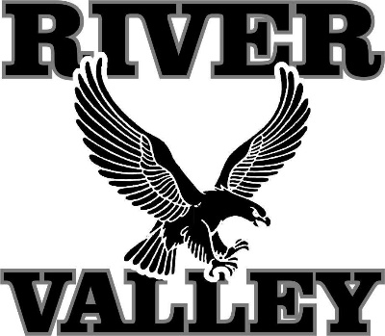
River Valley School District Strategic Plan
CHAMBER OF COMMERCE WORKSHOP
Chamber Office
February 13, 2018

Members of Chamber Board, other Chamber members, and the Chamber Director participated in this workshop (10 total). The purpose was to gain input on strategic issues that participants believed the River Valley School District (RVSD) is and will be confronting over the next two to five years, and potential strategies to address those issues. The District’s consultant asked participants to respond to results of community workshops held in late 2017, and to identify their own issues and strategies that the RVSD may consider. The following summarizes the input:
- Co-marketing with the Chamber makes sense. Chamber should be helping recruit more residents too. Recent collaboration has been with Area Guide and job fair.
- The job fair seemed to provide too much emphasis on finding a short-term/summer job, and not enough on finding a career.
- School District pieces in Area Guide and other publications should focus more on storytelling and student photos than statistics.
- Chamber and District should collaborate on more family-friendly activities.
- Think about visitor-oriented destinations and events, and have a School District marketing handout at each.
- Local business executive indicated that younger recruits feel they need to live in Middleton or Cross Plains, and are not impressed by the housing options in the Spring Green area.
- District and Chamber could reach out to real estate professionals to learn how the District could improve marketing, and how real estate pros could help.
- Chamber board members and others should also absorb talking points about the River Valley area to share a clear and consistent message with others.
- Are the right people engaged in marketing the District? How can we expect a school district administrator to be good at marketing too?
- District should market its small class sizes and very low crime—friendliness, personal touch.
- District should ask residents how they want communications (what modes).
- Seeming decline in arts focus in schools is a loss, and restoring it would be a differentiator. Discussion of believe that RVSD students do not visit Taliesin anymore because of bussing expense. Counterpoint: quality of plays and mock trial remain high.
- While many teachers are loyal to the District, teacher retention is an issue.
- District should take greater advantage of teacher specializations at the lower grades (e.g., if 4th grade teacher is good at/interested in math, why should she teach to only her class?)

