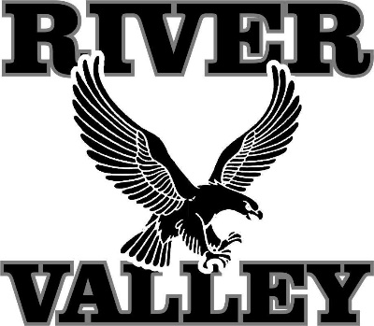
River Valley School District Strategic Plan
HIGH SCHOOL STUDENT WORKSHOP
River Valley High School
February 16, 2018

14 high school students participated in this workshop. The purpose was to gain input on strategic issues that participants believed the River Valley School District (RVSD) is and will be confronting over the next two to five years, and potential strategies to address those issues. The District’s consultant asked four broad questions, listed below. Student responses are bulleted.

- Are you satisfied with what the RVSD offers? What could be better?
- Running some AP courses every other year makes it difficult to get onto schedules.
- On-line is not a good substitute for many students—not as much control over offerings.
- “Blackhawk Period” –a one-hour study period—is very helpful. But should allow more travel between classes.
- Band, choir, forensics, etc. are strong. Even with declining enrollment, need to maintain these.
- All teachers are pretty good, and departments are good. High school math might need the most improvement; there might be different teaching methods and grading approach within department.
- Have great principal and administration.
- Overall experience is friendly, homey.
- Parking—each student has to pay $100/year. This is high. Where does this money go? If it went to transportation improvements or parking lot, there would be greater understanding. It’s obvious it doesn’t go into parking lot. If it was lower, maybe difference could be made up with sports fees.
- Middle school library looks better than it used to. Otherwise, middle school is dark. In general, renovated spaces look good, but put the non-renovated spaces in stark contrast.
- Architecturally schools are welcoming.
- Difference of opinion on quality of schools, especially relative to other districts.
- District should allow/promote teachers to personalize their classrooms, and update them. Psychology of space matters.
- Heating has been a problem at high school; cold and inconsistent in different parts .
- Some teachers have smart boards, but don’t use them. District is maybe at a weird transition with technology.
- Sometimes internet at high school is a problem—very unreliable—hard to login.
- All students ought to have Chromebook. Some teachers embrace; some do not. Interactive elements (e.g., videos) can be a problem—a lot of buffering. More training on Chromebook on how to download (e.g., to get word processing) should be provided.

- Are you satisfied with what the RVSD community offers? What could be better?
- “Like a Hawk” helps bring community together.
- Was hard to integrate from Arena elementary school to middle school (size, groups formed).
- School closures have created a somewhat hostile community environment, but this does not translate much for students. Students don’t care as much about change—they know they will fit in eventually. Change seems harder on parents.
- Long bus rides are the biggest problem with school consolidation.
- Perception of a Spring Green “haughtiness” was exacerbated by school closures. Hopeful that this will come to end with actual school consolidation experience.
- Challenge is with jobs in the area, and too far for comfortable commute to Madison.
- Spring Green is becoming more of retirement community.
- Build a brand on small-town appeal and strong academics.
- Summer activities—lots of sports camps here. A lot of students revolve around sports.
- What would it take for you to stay? For you to come back after college?
- “I’m not going to come back to small town.”
- “I will come to visit, but want to live in a city.”
- “I’m planning to live in a city—a place with a lot of opportunity.”
- “I would love to come back here, when I’m 60.”
- “I might feel obligated to come back.”
- “I plan to come back, just don’t know when.”
- “I don’t think the River Valley area offers what I want professionally.”
- “There’s nothing to do here.”
- “I want to have a lot of different people and opportunities.”
- “There are more job opportunities in what I want to do elsewhere.”
- “I definitely will be coming back for summers.”

- What one thing do you think the RVSD needs to do to provide the next generation of students with the same or better educational experience that you had?
- Improve school infrastructure.
- Keep the good teachers here—keep salaries competitive.
- Continue to provide students respect like they do today.
- Is more consolidation going to be necessary?
- Security and ensured safety—lots of unnecessary access to high school building (but have enjoyed the freedom).
- Create a clear procedure for emergency situation—“administrative hold” approach can be confusing.
- Improve marketing of what the District and its schools do well.

